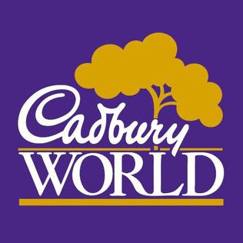
Your Beaver has been invited to District Beaver trip to Cadbury World, Birmingham on Saturday 5th October.
The Beavers will get to see where chocolate comes from and how chocolate is made, have a go at tempering/writing with chocolate, experience a 4D chocolate adventure and of course lots of chocolate tasting!

The trip will cost £24 which covers the coach and entry to the attraction.
The day will run from approximately 8:30am until 5:30pm however exact times will be confirmed nearer the time and given to you by your leader.
As this is a day event the Beavers will need to bring their own packed lunch and enough drink
to last them the day. This will need to be in a rucksack that they will carry throughout the day. Please can they also bring a pencil with them as they will require one for the tour.

Beavers can bring a maximum of £5 spending money with them in a purse or wallet with their name on it.
If you have any questions, please ask your leaders and they will pass them on if necessary.
The District Beaver Team

Please return to your Beaver leader by / /2019

I give permission for ____________________to attend the Beaver trip to Cadbury World.

I enclose £24 for the trip.

Signed______________________ Date____________

